SCREEN SHOT

Home Component

Login Component

Signup Component

Address Component

Checkout-Payment Component

Previous Order Component

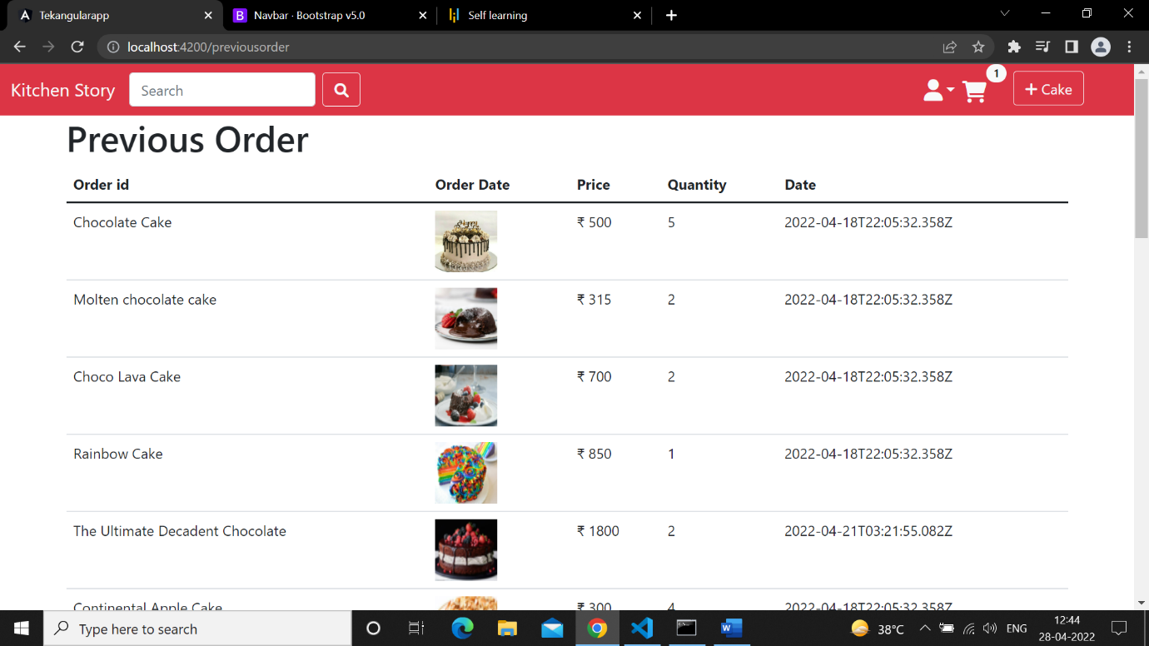

Cart Component

Forget Component

